

WATER AND ENVIRONMENT INFORMATION SYSTEM

PERMITS & COMPLIANCE MANAGEMENT PORTAL

USER MANUAL

JUNE 2023

Contents

1. INTRODUCTION. 3

2. Accessing the database. 3

3. The commissioner Dashboards. 4

i. External User. 4

4. Assistant commissioner/ commissioner. 9

5. Permits compliance database. 9

6. Compliance Management database. 10

a. Home Screen. 10

b. Compliance Level Assessment Form (CLAF) 10

c. Permits CLAF History. 11

d. Reports. 11

e. Querry builder. 12

7. FAQs and Trouble Shooting. 12

1.1. Troubleshooting guidelines. 12

1.2. Common technical Issues and solutions. 12

1.3. Files Uploading and Download issues. 12

1.4. Reporting Technical Issues. 12

# INTRODUCTION.

browser (such as Chrome, Firefox, or Edge) on your computer or mobile device. The permits Management portal is a product of the Water and Environment Information System phase two implementation. This was initiated in 2001 and the first implemented in 2018 with a number of both local and international companies coming together to deliver this product. It was first named the ‘WIS’ and later modified to ‘WEiS’ after bringing other units/departments like the Forests Sector Support Department on board.

## Accessing the database.

* Launch your preferred web
* Type the permits management database URL in the address bar of your web browser then “enter”.

1. **am logging in.**

All users shall be able to access the database using the different “user login credentials” that shall also determine the user rights/ privileges granted to them.

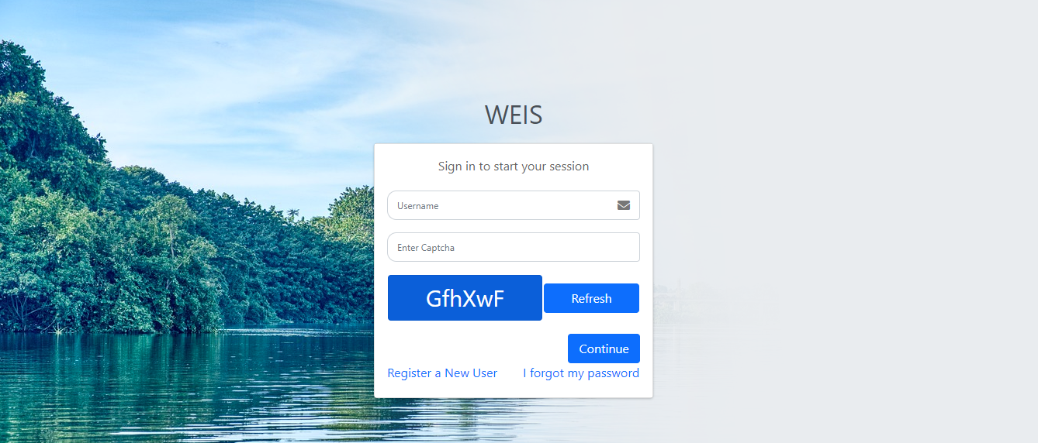 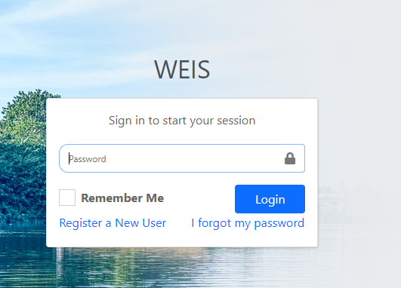

*The login page and procedure are the same at all login stages. The system shall prompt the user to enter the correct login details for them to access the database.*

1. **User roles and Permissions.**

The system grants the user access according to the user role by which they access the portal and different access roles come with different user privileges. the system has different user roles namely with different user rights following their respective designation.

* Commissioner
* Assistant commissioner.
* Principal water officer.
* Senior water officer.
* Water officer
* Data Assistant.
* External user.

## The commissioner Dashboards.

### External User.

After logging in, the external user dashboards are displayed below. The user shall be able to navigate through the system by “selecting’ and “clicking” the specific database field as required.

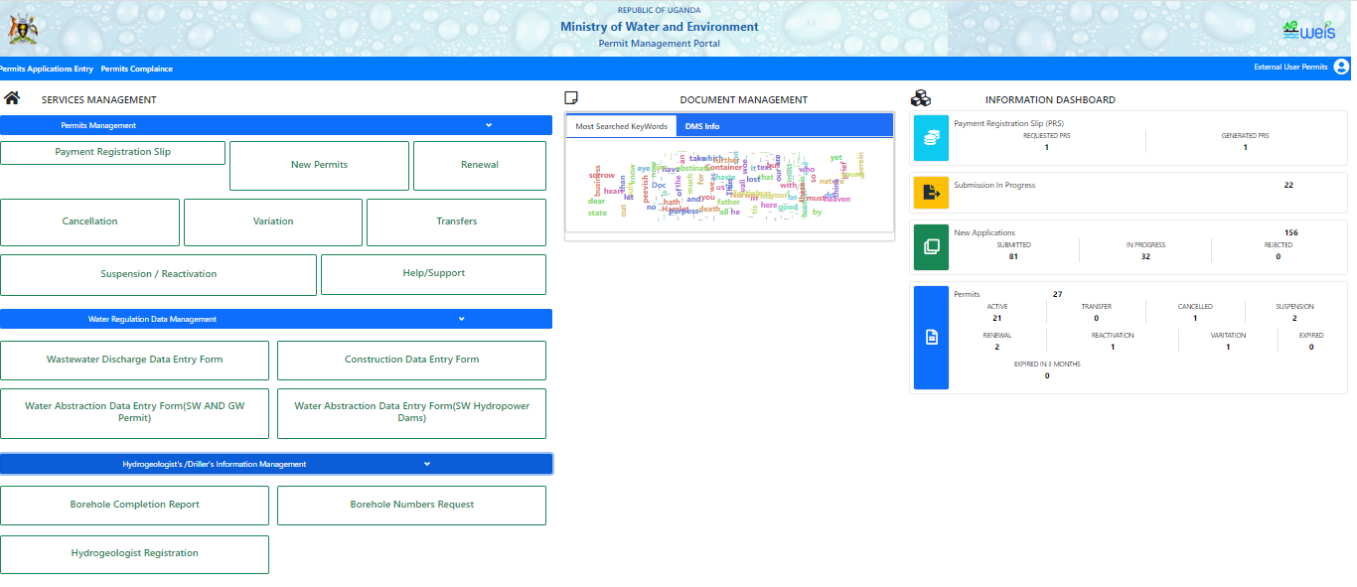

Click “new permit” to apply for new construction, easement, drilling, groundwater abstraction, surface water abstraction, and wastewater discharge permit application as required.

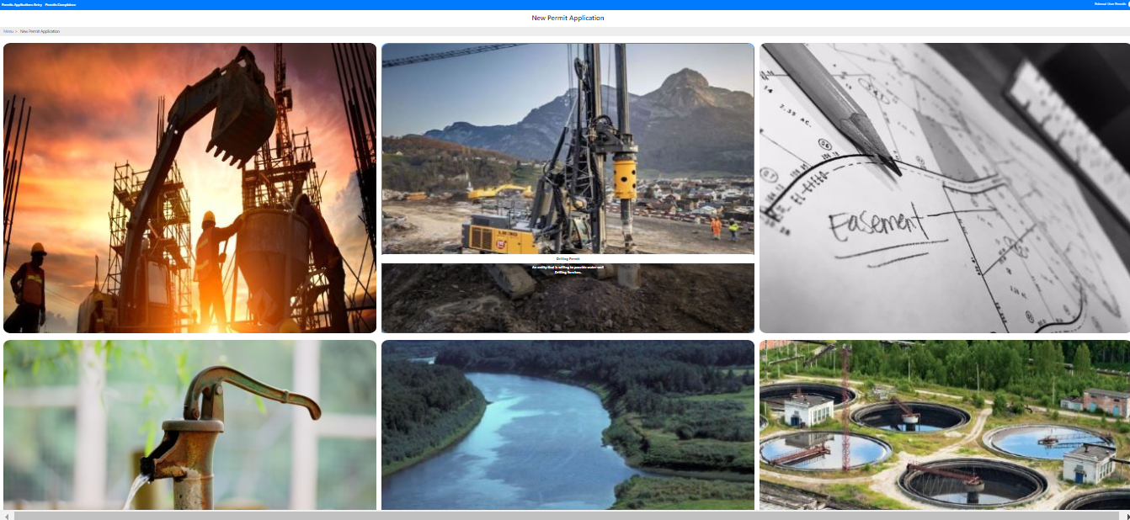

1. Permits applications.

The screen below shows a construction permit application. Click “the arrow” at every stage to enter information as required.

1. **Construction Permit.**

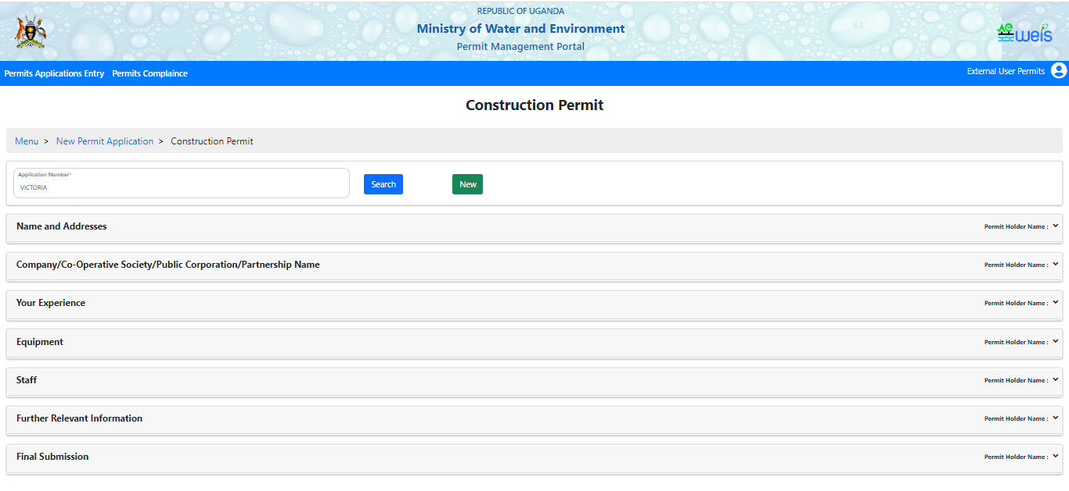

The screen below shows the **drilling permit** application; Enter the permit number in the space provided click “search” to get that particular drilling permit information or click “**new**” to enter new permit details then proceed with the data entry.

1. **Drilling Permit.**

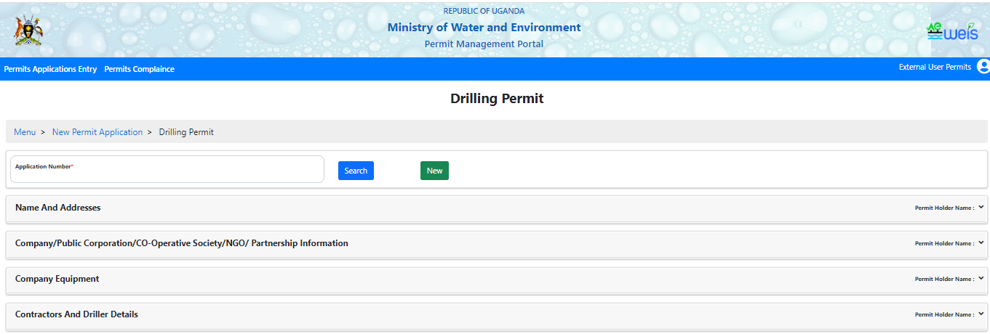

1. **Easement Permit.**

The user shall click “search” after entering a permit number to view details of the particular permit number. Click “new” to enter new permit details in case the permit number entered does not exist. Therefore, select “new” to enter the new permit number.

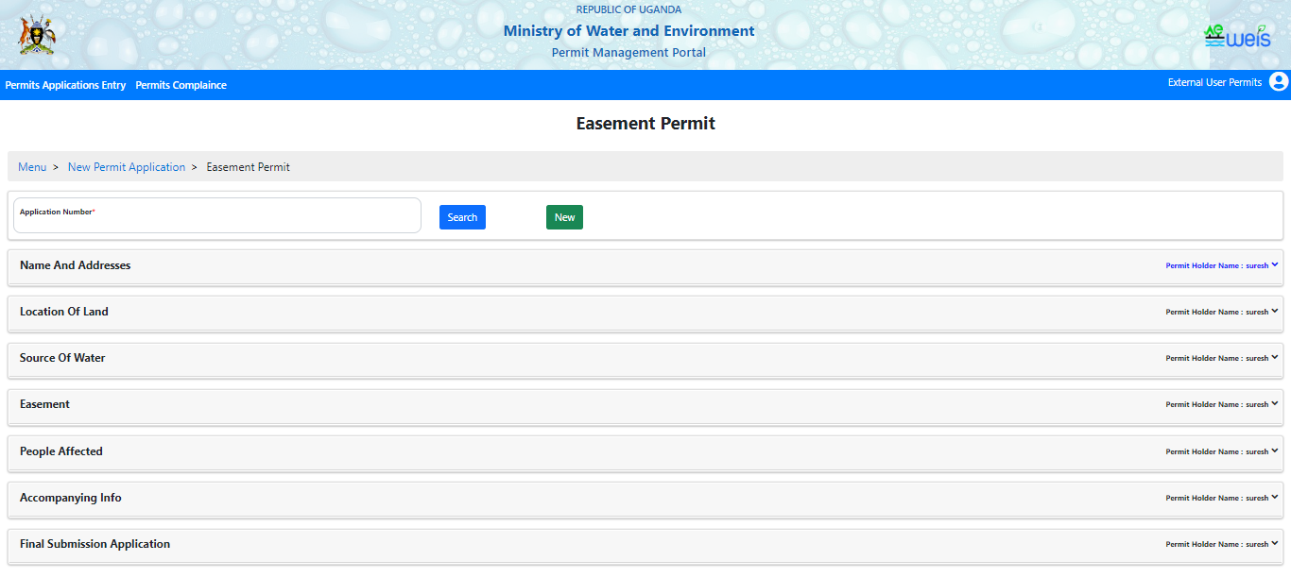

1. **Groundwater abstraction Permit**.

The screen below shows the groundwater abstraction permit click “the drop-down arrow” for more information / to enter information as required for the application.

For every mandatory (*/*) field in the forms; the system shall not save/ submit/ update if the field is not filled.

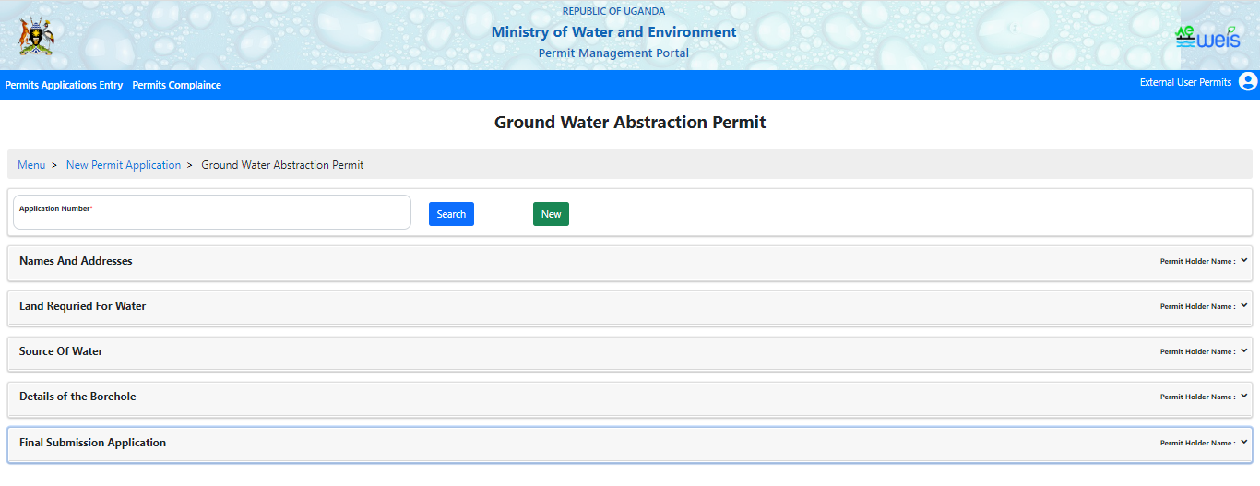

1. **Surface water abstraction Permit.**

The screens below show the surface water abstraction permit and the wastewater discharge permit.

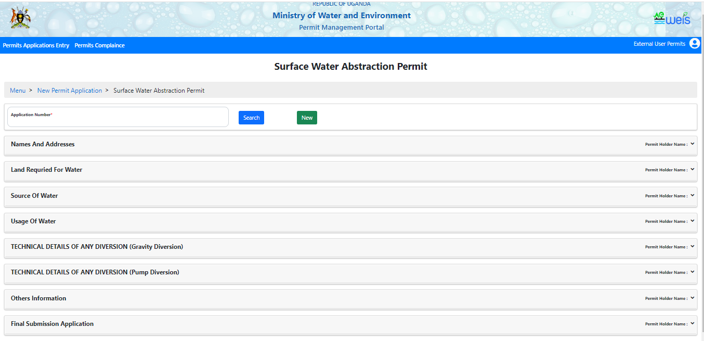 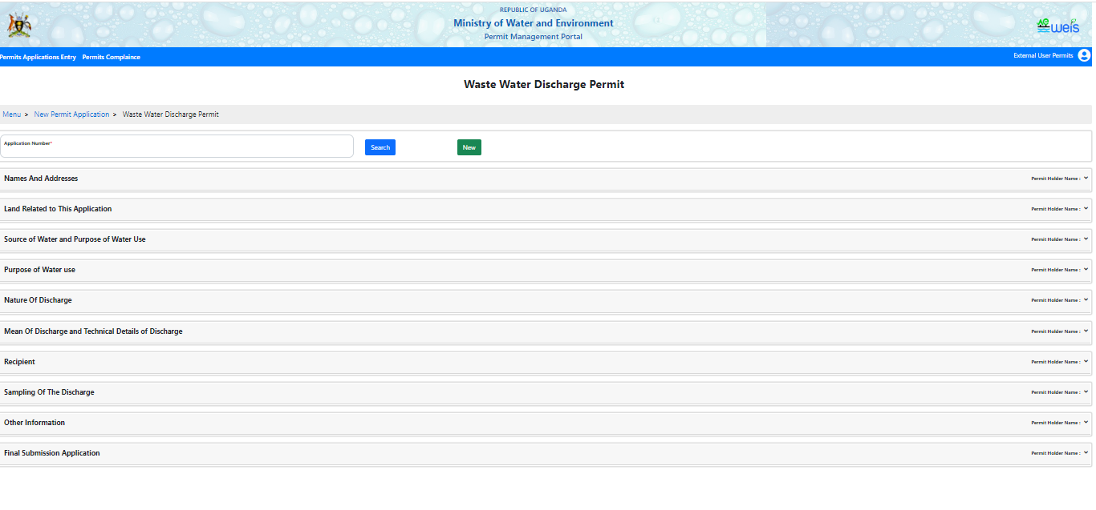

1. **Permit cancellation.**

If the user needs to cancel the previously approved permit, the permits management portal provides a straightforward process for submitting a permit cancellation request through the form displayed in the screen below.

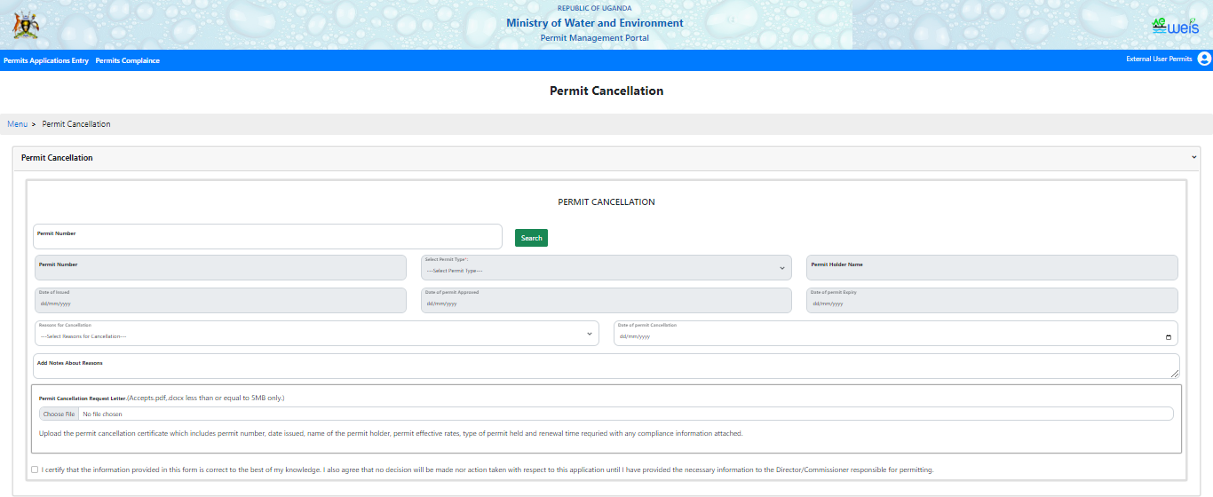

1. **Permit Variation**.

In case the user may need to make changes or modifications to an existing permit, the user shall initiate a permit variation request through the permits management portal.

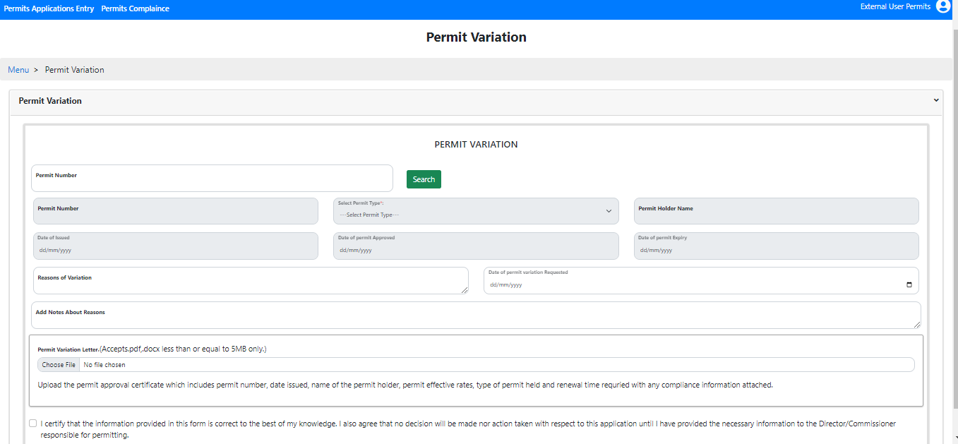

1. **Permit Transfer.**

If the user needs/ may be required to transfer an approved permit from one place to another, the permits management portal offers a convenient process for submitting a permit transfer request.

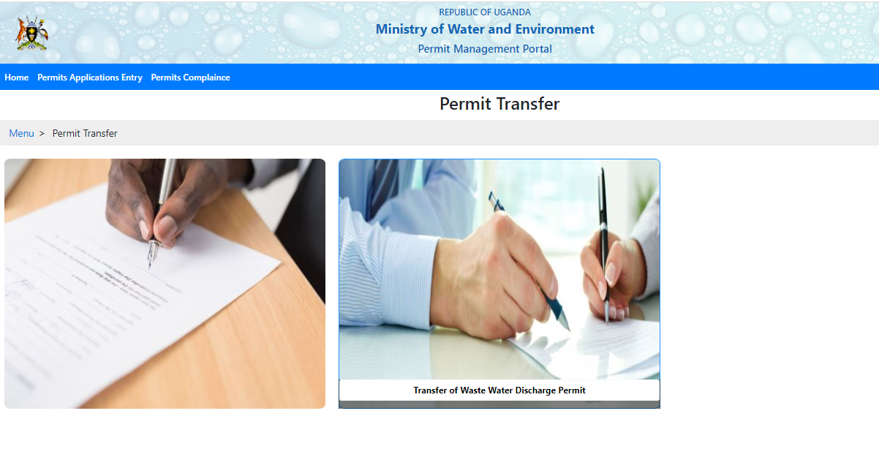

1. **Permit Help/Support.**

In the permit Help/ Support section the user shall be able to type in the reason/issue in the “reasons for Help/Support” section and also upload relevant documents to expedite the process.

*The system shall only accept pdf and docx less than or equal to 5MB.*

